CASE STUDY — ThinkVerse Labs
Standardising Cloud Infrastructure at Scale — AWS Multi-Environment Platform for a High-Volume Software Delivery Operation

1. Client Overview
ThinkVerse Labs is a custom software development and IT outsourcing firm headquartered in Noida, India. Over more than a decade, the company has delivered 500+ software projects across web, mobile, blockchain, AI, and AR/VR for 200+ clients spanning multiple geographies. With project teams operating concurrently across a growing client base, ThinkVerse Labs runs a high-throughput delivery model that demands reliable, repeatable cloud infrastructure at scale.
2. The Challenge
As ThinkVerse Labs scaled its client delivery operations, managing cloud environments across hundreds of concurrent projects became operationally complex. Key pain points included:
- Environment sprawl — Each project required isolated dev, staging, and production accounts, which were provisioned manually and inconsistently.
- No standardisation — Infrastructure configurations varied widely across teams, leading to drift, security gaps, and cost overruns.
- Slow onboarding — Spinning up a new client environment took several days of manual effort across multiple teams.
- Cost visibility — With 200+ active clients across shared and dedicated accounts, tracking spend per project or client was difficult.
- No governance layer — There was no centralised mechanism to enforce security policies, tagging standards, or access controls at scale.

3. The Solution
Kiwi Koru Limited designed and implemented a standardised, multi-account cloud infrastructure platform built on AWS, enabling ThinkVerse Labs to provision, govern, and manage environments across all projects from a single operational model.
- Multi-Account Landing Zone: Structured AWS Organizations with dedicated Organizational Units (OUs) for dev, staging, and production workloads. Each client project was assigned a governed account boundary with baseline policies applied automatically at provisioning.
- CloudFormation StackSets: Deployed StackSets across all accounts to enforce consistent IAM roles, VPC baselines, logging configurations, and security controls — eliminating manual per-account setup.
- Reusable Template Library: Built a curated library of parameterised CloudFormation templates covering common ThinkVerse Labs project archetypes — web applications, mobile backends, blockchain nodes, and AI workload environments. Templates were version-controlled in CodeCommit with changelogs maintained per release.
- CI/CD with CodePipeline: Implemented automated deployment pipelines that ran cfn-lint and cfn-nag validation, executed change sets, and deployed approved stacks — removing manual intervention from the infrastructure release process.
- Drift Detection & Change Management: Configured scheduled CloudFormation drift detection across all active stacks. Any configuration drift triggers alerts and requires a reviewed change set before remediation — maintaining infrastructure integrity across all environments.
- Tagging & Cost Allocation: Defined a mandatory tagging taxonomy (client ID, project code, environment, owner) enforced via AWS Config rules, enabling precise cost attribution across the full portfolio.

Solution Architecture
Component | Purpose
AWS Organizations | Structured Organizational Units (OUs) for dev, staging, and production workloads. Each client project assigned a governed account boundary with baseline policies applied automatically at provisioning.
CloudFormation StackSets | Deployed cross-account to enforce consistent IAM roles, VPC baselines, logging configurations, and security controls — eliminating manual per-account setup.
Reusable Template Library | Curated library of parameterised CloudFormation templates covering 5 standard project archetypes — web applications, mobile backends, blockchain nodes, and AI workload environments. Version-controlled in CodeCommit.
CodePipeline (CI/CD) | Automated deployment pipelines running cfn-lint and cfn-nag validation, executing change sets, and deploying approved stacks — removing manual intervention from the infrastructure release process.
Drift Detection | Scheduled CloudFormation drift detection across all active stacks. Configuration drift triggers alerts and requires a reviewed change set before remediation — maintaining infrastructure integrity across all environments.
AWS Config & Tagging | Mandatory tagging taxonomy (client ID, project code, environment, owner) enforced via AWS Config rules, enabling precise cost attribution across the full portfolio.

AWS Services Used
AWS Organizations | CloudFormation StackSets | CodePipeline | CodeCommit
IAM | S3 | VPC | AWS Config

4. What Was Delivered
- Multi-account AWS landing zone with structured OUs and baseline SCPs via AWS Organizations.
- CloudFormation StackSets configured for cross-account deployment of security, networking, and logging baselines.
- Reusable CloudFormation template library with parameterised stacks for 5 standard project archetypes.
- Automated CI/CD pipeline with integrated template linting, static analysis, and change set review gates.
- Drift detection framework with alerting and remediation workflows across all active stacks.
- Tagging taxonomy and AWS Config rules for enforced cost attribution and compliance reporting.
- Runbooks and handover documentation enabling ThinkVerse Labs teams to self-serve new environment provisioning.

Deliverables Detail
Workstream | Details
Multi-Account Landing Zone | Structured AWS Organizations with dedicated OUs and baseline SCPs applied automatically at provisioning, giving every client project a governed account boundary.
CloudFormation StackSets | Cross-account deployment of security, networking, and logging baselines — consistent configuration across all environments without manual per-account effort.
Reusable Template Library | Parameterised CloudFormation stacks for 5 standard project archetypes — version-controlled in CodeCommit with changelogs maintained per release.
Automated CI/CD Pipeline | Template linting, static analysis (cfn-lint, cfn-nag), and change set review gates integrated into CodePipeline for zero-manual-intervention infrastructure releases.
Drift Detection Framework | Scheduled drift detection with alerting and remediation workflows across all active stacks — infrastructure integrity maintained proactively.
Tagging & Cost Allocation | Mandatory tagging taxonomy with AWS Config enforcement — enabling per-client cloud spend attribution and compliance reporting for the first time.
Runbooks & Handover Docs | Self-service provisioning runbooks and handover documentation enabling Thinkverse Labs teams to spin up new environments independently.

4.1 Architecture Diagram
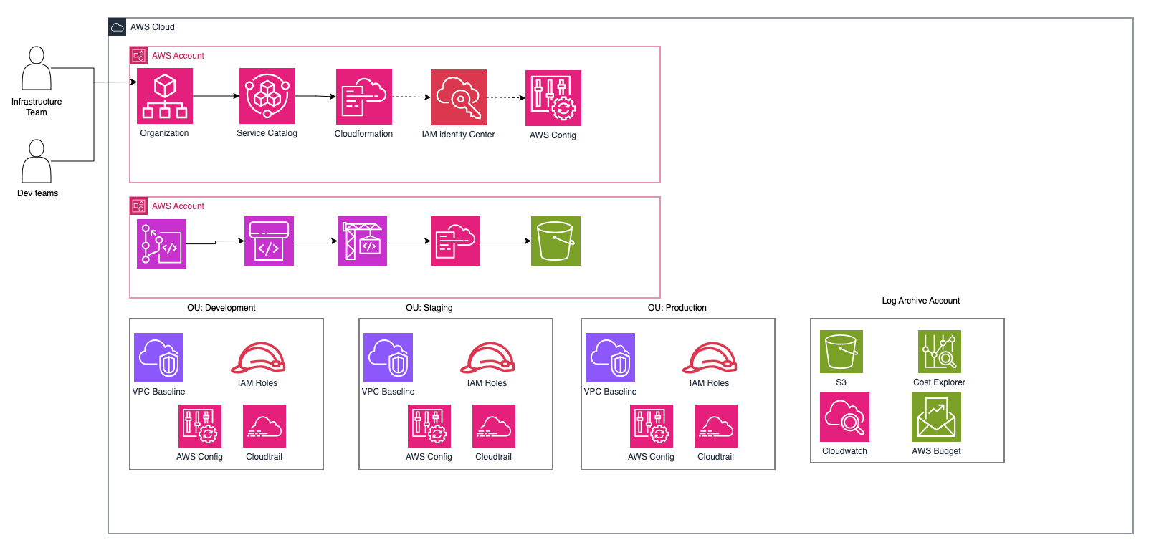

5. Outcomes & Impact
Metric | Result
70% Faster | Environment provisioning time — new client environments that previously took several days of manual effort across multiple teams now complete in under two hours using the self-service workflow.
40% Cost Reduction | Infrastructure cost reduction achieved through standardised templates, mandatory tagging, and precise cost attribution — enabling the finance team to produce per-client cloud spend reports for the first time.
< 2 Hours | Developer onboarding time (previously measured in days) — self-service account vending pipeline enables teams to provision fully configured environments without infrastructure team involvement.
Proactive Drift | Infrastructure drift, previously undetected until incidents occurred, is now identified and resolved proactively via scheduled detection and automated alerting — maintaining integrity across all environments.

The platform transformed how ThinkVerse Labs manages cloud infrastructure. What previously required days of coordination across infrastructure and DevOps teams — creating accounts, configuring VPCs, setting IAM policies, and wiring up CI/CD — now takes under two hours using the self-service provisioning workflow.
Standardised templates and mandatory tagging removed the cost visibility gap, enabling the finance team to produce per-client cloud spend reports for the first time. Infrastructure drift, previously undetected until incidents occurred, is now identified and resolved proactively.
The result is a leaner, more predictable delivery operation capable of supporting continued growth without a proportional increase in infrastructure overhead.

6. About Kiwi Koru Limited
Kiwi Koru Limited is a cloud architecture and engineering consultancy helping technology companies design, build and operate scalable, resilient systems on AWS. We bring deep expertise in high-availability architecture, real-time data platforms, infrastructure governance, and production infrastructure engineering.

